CSA0502 – QUERY PROCESSING FOR DATASCIENCE
Lab Programs

15. Keep Rows with at Least 2 NaN Values
Aim
To display rows containing at least two NaN values.
Code
import pandas as pd
import numpy as np

data = {
"A": [1, np.nan, np.nan, 4],
"B": [np.nan, np.nan, 3, 4],
"C": [1, np.nan, np.nan, np.nan]
}

df = pd.DataFrame(data)

print("Original DataFrame")
print(df)

result = df[df.isnull().sum(axis=1) >= 2]

print("\nRows with at Least 2 NaN Values")
print(result)
Output
Original DataFrame

A B C
0 1.0 NaN 1.0
1 NaN NaN NaN
2 NaN 3.0 NaN
3 4.0 4.0 NaN

Rows with at Least 2 NaN Values

A B C
1 NaN NaN NaN
2 NaN 3.0 NaN
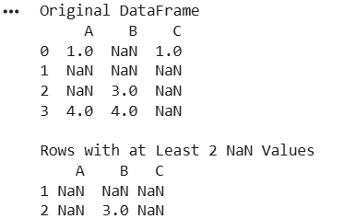
Result
Rows containing two or more NaN values were displayed successfully.

16. Split DataFrame into Groups Based on School Code
Aim
To split a DataFrame into groups based on School Code and check the type of the GroupBy object.
Code
import pandas as pd

data = {
"School_Code": ["S1", "S1", "S2", "S2", "S3"],
"Student": ["Alice", "Bob", "Charlie", "David", "Eva"],
"Age": [15, 16, 15, 17, 16]
}

df = pd.DataFrame(data)

print("Original DataFrame")
print(df)

group = df.groupby("School_Code")

print("\nGroupBy Object Type")
print(type(group))

print("\nGroups")
for name, data in group:
print("\nSchool Code:", name)
print(data)
Output
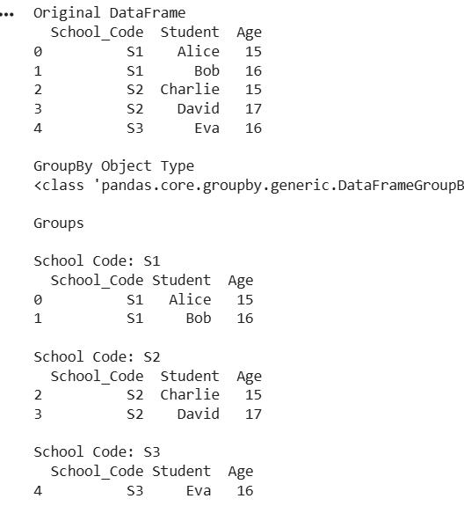
Result
The DataFrame was successfully grouped based on School Code.

